Attending a Catholic funeral service can prove to be a daunting and scary prospect, particularly if you are not of the Catholic faith yourself, therefore unfamiliar with the ceremony.
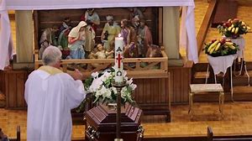

Catholic funeral order of service
A Roman Catholic funeral usually takes place as soon as possible after the death of a person. This would ideally be within a couple of days but certainly within a week. There is a strictly rigid defined order of service to a Catholic funeral, and it is as follows:

Prayer Vigil/Wake
This is held on the day before the funeral and may happen in church or at the family home. It is a gathering of relatives and friends to have some time with the body of their loved one before the funeral service takes place. This can be with an open or closed casket, however open is more traditional.
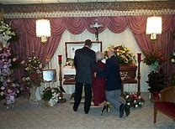
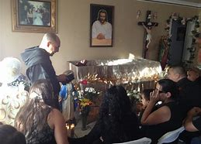
Although prayers take place at the vigil, with a sombre and reflective atmospheric tone the wake is not rigidly formal and non-religious music may be played and poetry and prose read. Mourners reminisce and share memories and anecdotes of the departed and prepare themselves mentally and spiritually for the service the next day.
Modern Catholic vigils/wake vary dependant on the ethnicity and personality of the deceased, how they lived and those of their family too.

The funeral
A Requiem Mass is the commonest type of funeral for individuals of the Catholic faith and includes the ceremony of Holy Communion. This is performed in order to fully commemorate the Ressurection and the spiritual resurrection of the departed’s soul.

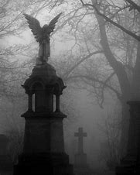

Catholic funerals are always traditionally held in Catholic churches, although in some places it is also possible to have it in a funeral home. The service will be held by a Catholic priest, who will deliver the sermon which will include commemorative pieces from the deceased’s life on earth.
There is a belief shared by all Christians whose faith dictates that depending on how you lived your life, these actions will determine whether you go to Heaven, Hell or Purgatory, the place designed for souls who have committed forgivable sins but who have yet to repent them.
Therefore to encourage this forgiveness, the Catholic funeral is used as a chance to appeal to God to be merciful on the departed soul. Therefore there are lots of prayers in a Catholic funeral and the deceased being spoken about as being with God in Heaven, in order to comfort those left behind.
It is not compulsory to have a full Requiem Mass during a Catholic, and often for those planning funerals where there will be a lot of guests attending that are not of the Catholic faith, having a Funeral Outside Mass is a common occurrence. However, it is encouraged by the Catholic Church to have a full mass service.
Regardless of this, there are some components of a Catholic funeral which are universal.
- The dress code for a traditional Catholic Funeral is extremely formal. Men should wear a suit and women should wear a dress or suit with smart shoes. All should be black in colour. It is appropriate for mourners to bring flowers to the service.
- The priest will greet the coffin at the door of the church and commence with sprinkling the coffin with holy water, he will then precede the mourners to the altar where the coffin will be covered over with a white pall.
- The service will consist of Bible readings, gospel and psalms, often read by friends and family although can be read by the priest. Traditional Catholic funeral hymns are sung. Non- Catholic mourners may sing along if they know the words, or simply remain stood and silent to show their respect to the dead and the faith.

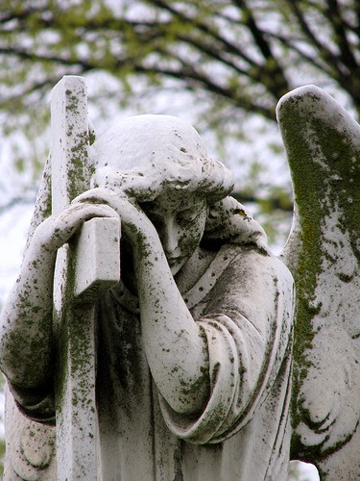

Therefore the order of service at a Catholic funeral is as follows:
- Introductory Rite, greeting by the priest
- Procession of priest, coffin, and congregation up the aisle
- Holy water sprinkled during the procession
- Opening song and prayers
- Readings from the Bible
- Holy Communion (Mass)
- More Prayers
- Holy water sprinkled on the coffin and incense burnt
- Coffin carried back down the aisle and out of the church
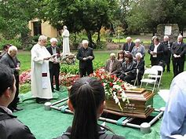
- Prayers said at the graveside (or before curtains close if it’s a cremation) for the Rite of the Committal

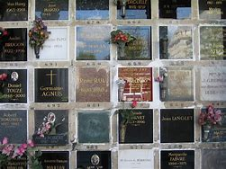
Burial remains the most traditional practice for laying the deas to rest in Catholicism, however, cremation has been allowed since the 2960’s. However, the scattering of ashes is strictly prohibited due to the Christian necessity of keeping the deceased’s remains together. Therefore cremains may be buried as long as they are entombed within a columbarium or buried at sea if they are sealed inside the container.
Reception
A Catholic reception can be held at the home of the deceased or of a family member/s. it could also be held at another venue such as a restaurant, community centre, pub or town hall.
It is a far less formal affair than the service itself and often includes items that allow people to remember the deceased’s life, these can include special items they had, photos, videos, the music they like and stories that people have.
The mood is often light-hearted with a celebratory atmospheric tone, alcohol and food are often consumed whilst remember and celebrating the departed. Mourners may offer gifts of food, alcohol, or flowers if they did not bring them to the funeral service, whereas some may donate money if the deceased died of an illness with a charity registered to it such as cancer and so forth.
Like the vigil, the reception is personalised and truly reflects the wishes, personality and lives of both the deceased and their nearest and dearest.

How long is a Catholic funeral?
Those who are not a part of the Roman Catholic faith may not know how long a Catholic funeral is carried out for, and the answer largely depends on whether the ceremony incorporates Holy Communion. An approximation is 30 minutes without a Mass and 60 Minutes with a Mass, maybe more depending on how many people have readings and how long they are.
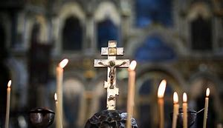
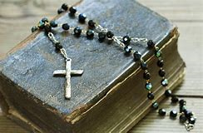

There may also be readings related to the deceased’s life achievements or a role in the parish, though eulogies are not a traditional part of Catholic funeral mass and may be omitted, depending on how contemporary or conservative the church is.If the funeral is a full Requiem Mass then Holy Communion is offered at this stage, if not, then final prayers will be offered to say a final farewell to the deceased’s soul.

Mourners may also wish to factor in time to offer their condolences to the family and other loved ones.

